**E-Commerce site with chatting application**

By:-

**Sharad Singh Rana 10BIT0106**

**Aneesh Goel 10BIT0179**

**Suchir Jain 10BIT0110**

**Guided by :**

**PROF SIVA RAMA KRISHNAN**

**BTECH -IT**

**School of Information Tech. & Engineering (SITE)**



**VIT**

U N I V E R S I T Y

(Estd. u/s 3 of UGC Act 1956)

**Executive Summary:**

|  |  |  |
| --- | --- | --- |
| 1.Introduction | 8 |  |
| 2 .Review Of Literature | **9** |  |
| 3.Proposed Architecture | **10** |  |
| 4.Detailed design | **14** |  |
| 5.Working Modules | **17** |  |
| 6.Results and Snapshots | **18** |  |
| 7.Conclusions | **19** |  |

|  |  |  |
| --- | --- | --- |
| **1.** | **Aim** | **2** |
| **2.** | **Objective** | **3** |
| **3.** | **Why did you choose?** | **4** |
| **4.** | **Background/literature survey** | **5** |
| **5.** | **Proposal** | **6** |

**TABLE OF CONTENT:**

|  |  |  |
| --- | --- | --- |
| 1.Introduction | 8 |  |
| 2 .Review Of Literature | **9** |  |
| 3.Proposed Architecture | **10** |  |
| 4.Detailed design | **14** |  |
| 5.Working Modules | **17** |  |
| 6.Results and Snapshots | **18** |  |
| 7.Conclusions | **19** |  |
| 8.Scope for Future work | **20** |  |
| 9.References | **21** |  |
| 10.Appendix | **22** |  |

**Aim:**

To make an e-commerce website where customers can buy and interact with each other.

**Objectives:**

**General:**

* To make a website where users can view and purchase items.
* The customers can add the items in the cart if they may consider buying it in the future.
* Those who have purchased a product can add review about the product.

**Specific:**

* The new idea we will implement is by adding chat application to it so that the customers can interact among themselves about the quality of a product before buying it and not have to rely on the reviews of the product alone.
* The customer who is being asked may choose to answer the question or not.
* We can also clarify our doubts about the configuration/description of the product given.

**WHY DID YOU CHOOSE?**

Because this website will cater to the needs of the people who want more authenticity in the products they purchase and want to discuss the product with the people who have already purchased it.

**Background/literature survey:**

Whenever we purchase something online we are always suspicious about the quality of the product and whether the product’s details given are correct. Currently no e-commerce site is providing the facility of interaction among the customers be it flipkart or inkfruit or infibeam or any of the numerous websites.

**Proposal:**

To make an e-commerce site where a user can ask another user who has already purchased a product about the quality of that product. There will be a list of users who have purchased the product and who can be asked about the finer nuances of the product and if they wish they can respond to it.

**Technologies Used:**

PHP, MySQL, HTML, CSS, Javascript

1. **Introduction**

E-commerce is fast gaining ground as an accepted and used business paradigm.

More and more business houses are implementing web sites providing functionality for performing commercial transactions over the web. It is reasonable to say that the process of shopping on the web is becoming commonplace. The objective of this project is to develop a general purpose e-commerce store where any product (such as books, CDs, computers, mobile phones, electronic items, and home appliances) can be bought from the comfort of home through the Internet.However, for implementation purposes, this report will deal with an online ecommerce store with chatting application.An online store is a virtual store on the Internet where customers can browse the catalog and select products of interest. The selected items may be collected in a shopping cart. At checkout time, the items in the shopping cart will be presented as an order. At that time, more information will be needed to complete the transaction. Usually, the customer will be asked to fill or select a billing address, a shipping address, a shipping option, and payment information such as credit card number. An e- mail notification is sent to the customer as soon as the order is placed.The Chatting application provides the ability to multi-task, the overall time expenditure is less than phone handling for most sites. As the Internet has matured, online shoppers have become savvier and are expecting more from online sellers. Increasingly, they want their online transactions backed up with **live customer support**, just as they would have in a brick and mortar store. According to a poll by Andersen Consulting, almost 62 percent of Internet consumers said they would purchase more products online if live customer support were available.

**2.Literature Review**

Electronic Commerce (e-commerce) applications support the interaction between different parties participating in a commerce transaction via the network, as well as the management of the data involved in the process [2].

The increasing importance of e-commerce is apparent in the study conducted by

researches. In their summary of the findings from the eighth survey, the researchers report that “e-commerce is taking off both in terms of the number of users shopping as well as the total amount people are spending via Internet based transactions”.

Over three quarters of the 10,000 respondents report having purchased items online.The Electronic Commerce (e-commerce) applications support the interaction between different parties participating in a commerce transaction via the network, as well as the management of the data involved in the process [2].

The increasing importance of e-commerce is apparent in the study conducted by

researches at the GVU (Graphics, Visualization, and Usability) Center at the Georgia Institute of Technology. In their summary of the findings from the eighth survey, the researchers report that “e-commerce is taking off both in terms of the number of users shopping as well as the total amount people are spending via Internet based transactions”.

Over three quarters of the 10,000 respondents report having purchased items online. The most cited reason for using the web for personal shopping was convenience (65%),followed by availability of vendor information (60%), no pressure form sales person(55%) and saving time (53%).Although the issue of security remains the primary reason why more people do not purchase items online, the GVA survey also indicates that faith in the security of ecommerce is increasing. As more people gain confidence in current encryption technologies, more and more users can be expected to frequently purchase items online

A good e-commerce site should present the following factors to the customers for better usability .

*   Knowing when an item was saved or not saved in the shopping cart.
*  Returning to different parts of the site after adding an item to the shopping cart.
*  Easy scanning and selecting items in a list.
*  Effective categorical organization of products.
*  Simple navigation from home page to information and order links for specific
* products.
*  Obvious shopping links or buttons.
*  Minimal and effective security notifications or messages.
*  Consistent layout of product information.
* Live support (chatting application)

Another important factor in the design of an e-commerce site is feedback The interactive cycle between a user and a web site is not complete until the web site responds to a command entered by the user. According to Norman , "feedback--sending back to the user information about what action has actually been done, what result has been accomplished--is a well known concept in the science of control and information theory.Imagine trying to talk to someone when you cannot even hear your own voice, or trying to draw a picture with a pencil that leaves no mark: there would be no feedback".

**3.Proposed Architecture**

For the high level architecture we will be using the Model-View-Controller (MVC) architectural design. In this design pattern, a model is an abstract representation of our data, a view is any presentation of data, and a controller handles events (e.g., user input).

For our project, the model is simply built on top of our database and the database itself, our views are simply the web pages a user interacts with. And our controller is a server side scripting language(PHP).

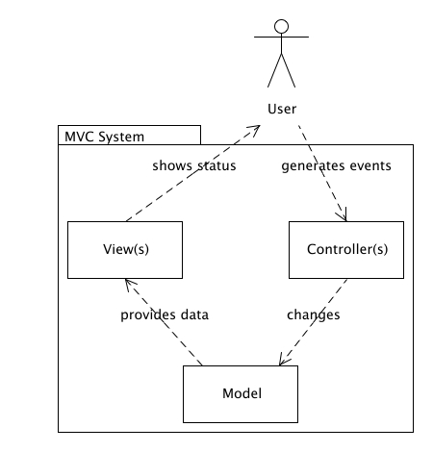

This method is very suitable for our needs as it decouples the presentation layer (HTML, CSS, images, etc) from the logic layer (database back-end and request handling). This allows us to easily change the website’s appearance without touching the underlying behaviour and logic i.e., we can change the presentation of our site without touching the database or scripting language.

**Database**

For our website we have used the relational database implemented using MySQL. We have used the primary keys of all tables to identify an individual record and also to perform operations on a single table and using foreign key we can perform operations on multiple tables.

We are having 3 tables in our database, one for storing customer details, one for storing the transactions i.e., the items bought and one for storing items in the cart which can be purchased later. All the tables are connected with each other using the primary key which the email id provided by the user.

The ER(Entity Relationship) diagram for the database is given below.

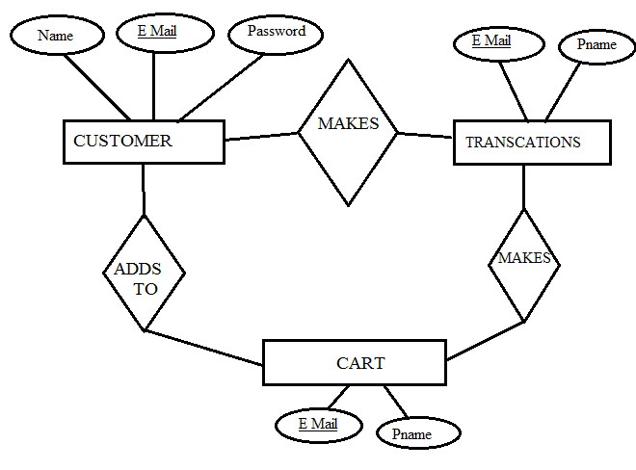

The database schema for the above diagram is

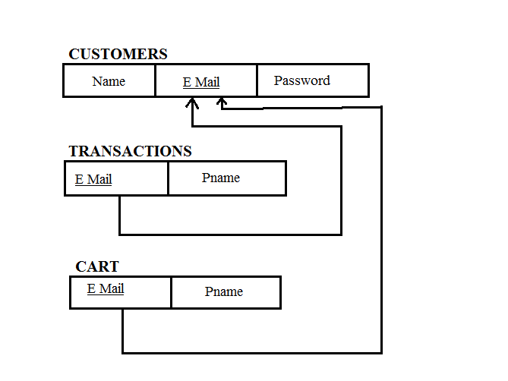

**Detailed Design (Low Level Design)**

**Use Case Diagram**

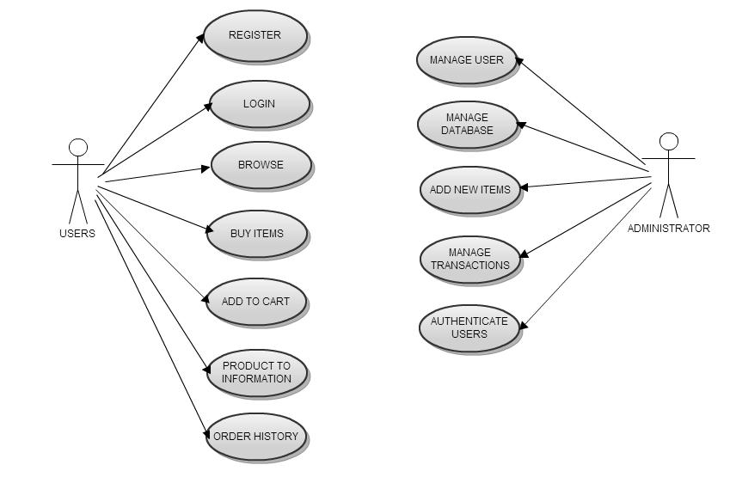

**Sequence Diagram**

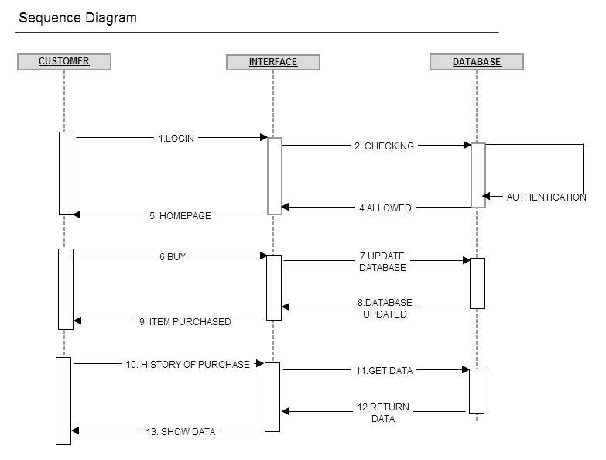

**Collaboration Diagram**

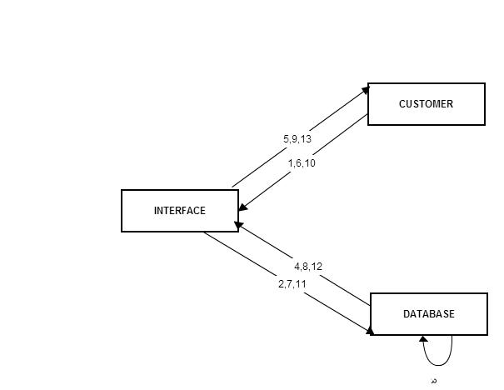

**State Diagram**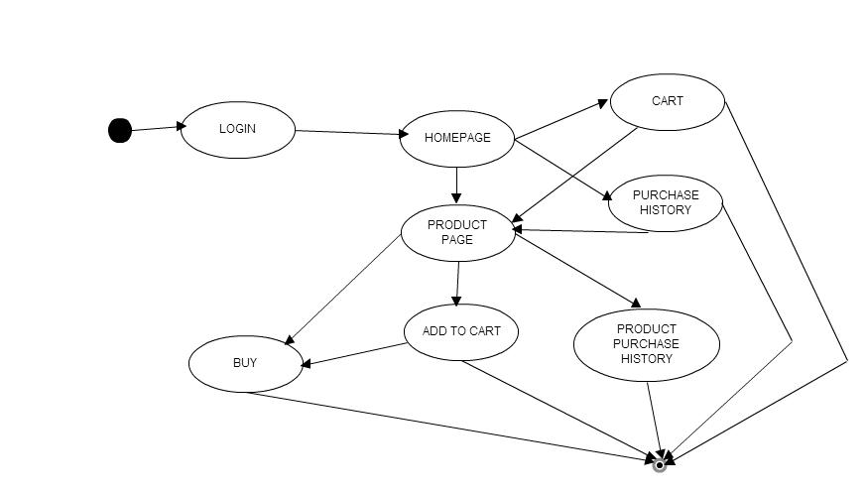

**Snapshots And Results**

1.Home

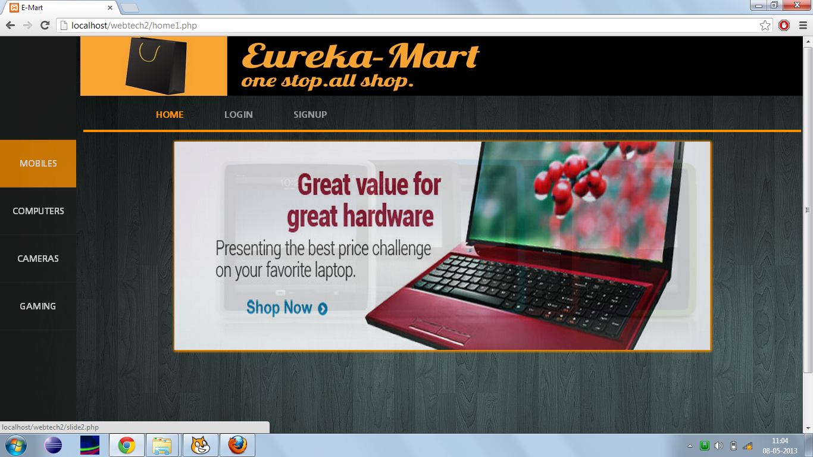

2. Messaging system

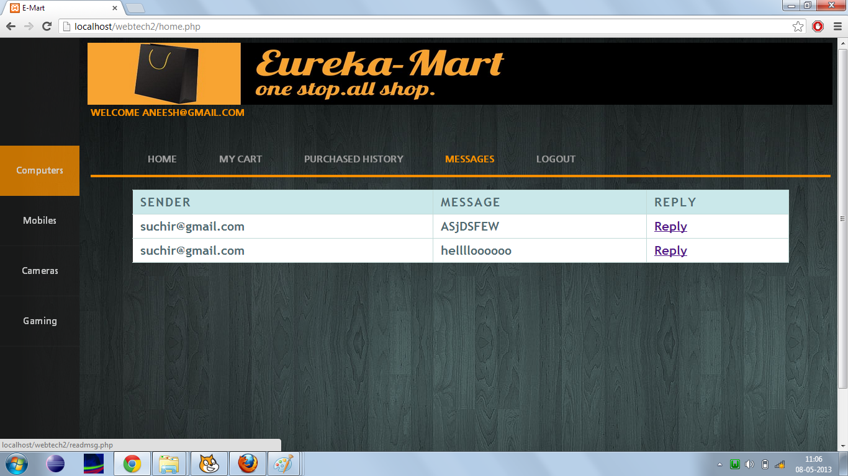

3.. Online store

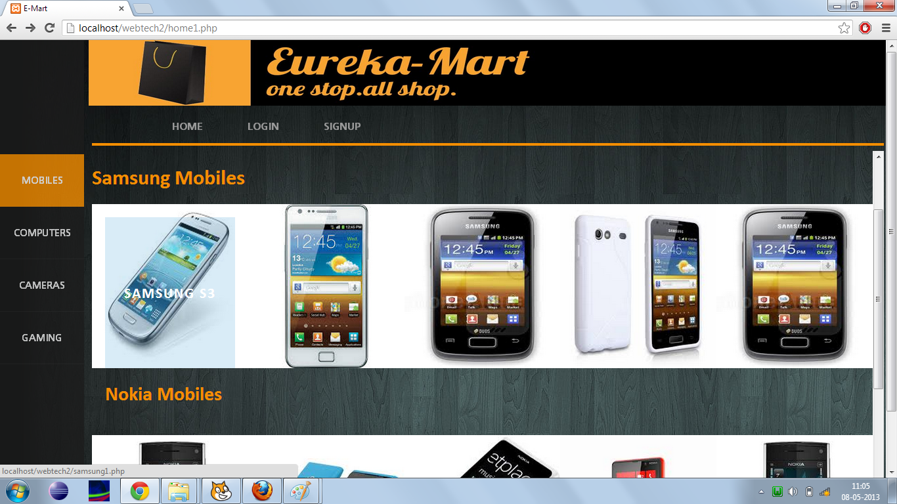

**Scope of the project:**

This website will cater to the needs of the people who want more authenticity in the products they purchase and want to discuss the product with the people who have already purchased it.

**Conclusion**

A good shopping cart design must be accompanied with user-friendly shopping

cart application logic. It should be convenient for the customer to view the contents of their cart and to be able to remove or add items to their cart. The shopping cart application described in this project provides a number of features that are designed to make the customer more comfortable

**References**

1. W3school.com
2. stackoverflow.com/
3. php.net/*‎*
4. www.html.net/*‎*
5. www.w3.org/html/*‎*
6. www.cssmania.com/*‎*

**Appendix**

**Working modules**

Home.php

<?php

session_start();

?>

<html>

<head>

<title>E-Mart</title>

<script>

function myFunction()

{

<?php

$a=$_POST["email"];

$b=$_POST["password"];

$_SESSION["mail"]=$a;

//header("location:mobiles.php");

?>

}

</script>

<style>

h4{

font-family:'font',Georgia,Cambria;

color:#F58E01;

}

a {

color: #f0f0f0;

text-decoration: none;

}

table {width:100%;

height:100%;}

td.a

{

width:10%;

height:10%;}

td.b

{

width:90%;

height:10%;

}

td.c

{

width:10%;

height:90%;}

td.d

{

width:90%;

height:90%;}

ul {list-style-type:block;}

.e

{

margin-left:70%;

}

.f

{

margin-left:80%;

}

/* ------------------------------------------------------------ */

@font-face {

font-family: 'font';

src:url('fonts/font.otf');

font-weight: normal;

font-style: normal;

}

.cbp-vimenu {

position: fixed;

overflow: hidden;

top: 0;

left: 0;

height: 100%;

list-style-type: none;

margin: 0;

padding: 0;

background: #1d1d1d;

padding-top:12.9%;

opacity:0.8;

}

.cbp-vimenu li a{

display: block;

text-indent:0em;

height: 5em;

width: 8em;

line-height: 5em;

text-align: center;

color: #f1f1f1;

position: relative;

border-bottom: 1px solid rgba(255,255,255,0.05);

-webkit-transition: background 0.1s ease-in-out;

-moz-transition: background 0.1s ease-in-out;

transition: background 0.1s ease-in-out;

}

.cbp-vimenu li a:hover,

.cbp-vimenu li:first-child a{

background: #F58E01;

color: #fff;

}

/* class for current item */

.cbp-vimenu li.active

{

background: #f1f1f1;

color: #222;

}

.cbp-vimenu li a:before {

font-family: 'ecoico';

speak: none;

font-style: normal;

font-weight: normal;

text-indent: 0em;

position: absolute;

top: 0;

left: 0;

width: 100%;

height: 100%;

font-size: 1.4em;

-webkit-font-smoothing: antialiased;

}

.cbp-vimenu li a.icon-logo:before {

content: "C";

font-weight: 700;

font-size: 300%;

font-family: 'Lato', Calibri, Arial, sans-serif;

}

.icon-search:before {

content: "\e004";

}

.icon-archive:before {

content: "\e005";

}

.icon-download:before {

content: "\e006";

}

.icon-location:before {

content: "\e007";

}

.icon-images:before {

content: "\e009";

}

.icon-pencil:before {

content: "\e008";

}

/* Example for media query (depends on total height of menu) */

@media screen and (max-height: 34.9375em) {

.cbp-vimenu {

font-size: 70%;

}

}

/* ********************************************************************************************************************************** */

.cbp-hrmenu {

width: 100%;

margin-top: 2em;

border-bottom: 4px solid #F58E01;

padding-top:0;

margin-top:0;

}

/* general ul style */

.cbp-hrmenu ul {

margin: 0;

padding: 0;

list-style-type: none;

}

#gtc{

color:#F58E01;

}

/* first level ul style */

.cbp-hrmenu > ul,

.cbp-hrmenu .cbp-hrsub-inner {

width: 90%;

max-width: 70em;

margin: 0 auto;

padding: 0 1.875em;

}

.cbp-hrmenu > ul > li {

display: inline-block;

}

.cbp-hrmenu > ul > li > a {

font-weight: 700;

padding: 1em 2em;

color: #999;

display: inline-block;

}

.cbp-hrmenu > ul > li > a:hover {

color: #F58E01;

}

.cbp-hrmenu > ul > li.cbp-hropen a,

.cbp-hrmenu > ul > li.cbp-hropen > a:hover {

color: #fff;

background: #F58E01;

}

/* sub-menu */

.cbp-hrmenu .cbp-hrsub {

display: none;

position: absolute;

background: #F58E01;

width: 90%;

left: 9.5%;

}

.cbp-hropen .cbp-hrsub {

display: block;

padding-bottom: 3em;

}

.cbp-hrmenu .cbp-hrsub-inner > div {

width: 33%;

float: left;

padding: 0 2em 0;

}

.cbp-hrmenu .cbp-hrsub-inner:before,

.cbp-hrmenu .cbp-hrsub-inner:after {

content: " ";

display: table;

}

.cbp-hrmenu .cbp-hrsub-inner:after {

clear: both;

}

.cbp-hrmenu .cbp-hrsub-inner > div a {

line-height: 2em;

}

.cbp-hrsub h4 {

color: #ffee00;

padding: 2em 0 0.6em;

margin: 0;

opacity:0.8;

font-size: 160%;

font-weight: 300;

}

body

{

font-family:font;

}

/* ---------------------------------------- */

#imgheader{

background-color:black;

margin-left:10%;

padding-bottom:0;

// position:fixed;

//z-index:19001;

}

</style>

</head>

<body background="main.jpg">

<div id="imgheader" >

<img src="test3.jpg" width="1000px" height="100px"></div>

<table >

<tr>

<td class="a"></td>

<td class="b">

<?php

$a=$_POST["email"];

$b=$_POST["password"];

$con=mysqli_connect("localhost","root","","persons");

if(mysqli_connect_errno())

echo "Problem in connecting with mysql";

$result = mysqli_query($con,"SELECT * FROM record");

$f=1;

while($row = mysqli_fetch_array($result))

{

if($a==$row['email'])

{

if($b==$row['password'])

{

$f=0;

break;

}

}

}

if($f==0)

{

echo "<h4>WELCOME ".$a."</h4><br>";

}

else

{

echo "<h4>Sorry your account doesnot exist.</h4>";

echo "<h4>Please Signup.</h4>";

echo "<a href='signup.php'>SIGNUP";

}

//$_SESSION['email']=$a;

//header("location:mobiles.php");

?>

<div class="main">

<nav id="cbp-hrmenu" class="cbp-hrmenu">

<ul>

<li>

<a href="slide2.php" target="iframe_a" onclick="myFunction()">HOME</a>

</li>

<li>

<a href="cart.php" target="iframe_a" onclick="myFunction()">MY CART</a>

</li>

<li>

<a href="history.php" target="iframe_a" onclick="myFunction()">PURCHASED HISTORY</a>

</li>

<li>

<a href="readmsg.php" target="iframe_a" onclick="myFunction()">MESSAGES</a>

</li>

<li>

<a href="logout.php" onclick="myFunction()">LOGOUT</a>

</li>

</ul>

</nav>

</div>

<!--<a href="cart.php" target="iframe_a" onclick="myFunction()">My Cart</a>

<a href="history.php" target="iframe_a" onclick="myFunction()">Purchase History</a>

<a href="readmsg.php" target="iframe_a" onclick="myFunction()">Messages</a>

<a href="logout.php" onclick="myFunction()">Logout</a> -->

</td>

</tr>

<tr>

<td class="c"><ul class="cbp-vimenu">

<li><a href="computers.php" target="iframe_a" onclick="myFunction()">Computers</a></li>

<li><a href="mobiles.php" target="iframe_a" onclick="myFunction()">Mobiles</a></li>

<li><a href="cameras.php" target="iframe_a" onclick="myFunction()">Cameras</a></li>

<li><a href="gaming.php" target="iframe_a" onclick="myFunction()">Gaming</a></li></ul></td>

<td class="d"><iframe src="slide2.php" frameborder='0' name="iframe_a" width="100%" height="100%">NO support</iframe></td>

</tr>

</table>

</body>

</html>

Readmsg.php

<html>

<style>

table {

width:90%;

border-top:1px solid #e5eff8;

border-right:1px solid #e5eff8;

margin:1em auto;

border-collapse:collapse;

}

td {

border-right: 1px solid #C1DAD7;

border-bottom: 1px solid #C1DAD7;

background: #fff;

padding: 6px 6px 6px 12px;

color: #4f6b72;

font: bold 20px "Trebuchet MS", Verdana, Arial, Helvetica, sans-serif;

}

th {

font: bold 20px "Trebuchet MS", Verdana, Arial, Helvetica, sans-serif;

color: #4f6b72;

border-right: 1px solid #C1DAD7;

border-bottom: 1px solid #C1DAD7;

border-top: 1px solid #C1DAD7;

letter-spacing: 2px;

text-transform: uppercase;

text-align: left;

padding: 6px 6px 6px 12px;

background: #CAE8EA url(images/bg_header.jpg) no-repeat;

}

</style>

<?php

session_start();

if(!isset($_SESSION["mail"]))

{

echo "no value passed";

}

else

{

//echo $_SESSION["mail"] ;

}

$a= $_SESSION["mail"] ;

$con=mysqli_connect("localhost","root","","persons");

// Check connection

if (mysqli_connect_errno())

{

echo "Failed to connect to MySQL: " . mysqli_connect_error();

}

$result = mysqli_query($con,"SELECT * FROM messages where msgto='$a' and messages.read='no'");

echo " <table border='1'>

<tr>

<th>Sender</th>

<th>Message</th>

<th>Reply</th>

</tr>";

while($row = mysqli_fetch_array($result))

{

echo "<tr>";

echo "<td>" . $row['msgfrom'] . "</td>";

echo "<td>" . $row['msg'] . "</td>";

echo "<td><a href='msg.php?email=".$row['msgfrom']."' onclick='return my()'>Reply</a></td>";

echo "</tr>";

}

echo "</table>";

mysqli_query($con,"update messages set messages.read='yes' where msgto='$a' and messages.read='no'");

mysqli_close($con);

?>

<body>

</body>

</html>

Login.html

<!DOCTYPE html>

<html lang="en">

<head>

<meta charset="utf-8" />

<title>Login</title>

<link rel="shortcut icon" href="../favicon.ico">

<link rel="stylesheet" type="text/css" href="css/default.css" />

<link rel="stylesheet" type="text/css" href="css/component.css" />

<link rel="stylesheet" type="text/css" href="css/headerimg.css" />

<link rel="stylesheet" type="text/css" href="css/style.css" />

<script src="js/modernizr.custom.js"></script>

</head>

<script src="modernizr.custom.63321.js"></script>

<!--[if lte IE 7]><style>.main{display:none;} .support-note .note-ie{display:block;}</style><![endif]-->

<style>

@import url(http://fonts.googleapis.com/css?family=Montserrat:400,700|Handlee);

.container > header h1,

.container > header h2 {

color: #fff;

text-shadow: 0 1px 1px rgba(0,0,0,0.5);

}

</style>

<script>

function validatel()

{

var x = document.forms["login"]["username"].value;

var y = document.forms["login"]["password"].value;

if(x.length==0)

{

alert("Enter Username");

return false;

}

if(y.length==0)

{

alert("Enter Password");

return false;

}}

</script>

</head>

<body>

<div class="container">

<header class="clearfix">

<nav>

<a href="home1.php" class="icon-arrow-left" data-info="home">Home</a>

</nav>

</header>

<h1>Login Please!!</h1>

<div id="horizontalline">

</div>

<section class="main">

<form id="login" class="form-5 clearfix" method="post" action="home.php" onsubmit="return validatel()">

<p>

<input type="text" name="email" id="username" placeholder="E-mail">

<input type="password" name="password" id="password" placeholder="Password">

</p>

<button type="submit" name="submit" >

<i class="icon-arrow-right"></i>

<span>Sign in</span>

</button>

</form>

</section>

</div>

<!-- jQuery if needed -->

<script type="text/javascript" src="http://ajax.googleapis.com/ajax/libs/jquery/1.8.2/jquery.min.js"></script>

<script type="text/javascript" src="jquery.placeholder.min.js"></script>

<script type="text/javascript">

$(function(){

$('input, textarea').placeholder();

});

</script>

</div>

</body>

</html>

**THANK YOU SIR**